Financial News Entity Extraction

Project Description
Financial News Entity Extraction is an advanced Natural Language Processing (NLP) project designed to automatically identify and classify key financial entities from unstructured news articles.
The system uses a Transformer-based *Named Entity Recognition (NER)* model trained *completely from scratch* (without using any pretrained model like BERT or RoBERTa).
It extracts meaningful financial information such as:
- Company Names (ORG)
- Stock Tickers (TICKER)
- Currency/Money Values (MONEY)
- Financial Events (EVENT)
- Dates & Economic Indicators (DATE)
This helps analysts, investors, and financial institutions summarize, understand, and act on financial trends faster and more accurately.

Project Scenarios
Scenario 1: Real-Time Financial News Monitoring
A user enters a news headline:
“Tesla announced a $5 billion investment plan on Monday.”
The system instantly extracts:
- Tesla → ORG
- $5 billion → MONEY
- Monday → DATE
- investment → EVENT
This enables analysts to automatically structure crucial information from incoming news streams.

Scenario 2: Stock Market Insights
Financial platforms integrate the system to automatically tag:
- company actions
- IPO details
- mergers & acquisitions
- earnings announcements
Example:
“Apple acquired PayPlus in a $2B deal.”
Extracted:
- Apple → ORG
- PayPlus → ORG
- $2B → MONEY
- acquired → EVENT

Scenario 3: Automated Financial Document Review
Banks and investment firms process:
- annual reports
- press releases
- financial bulletins
The system extracts entities with high accuracy, helping automate document analysis pipelines.

Technical Diagram
Raw Financial Text
↓
Data Preprocessing → Token Standardization
↓
SentencePiece Tokenizer Training
↓
Transformer Model (6-layer, 256 hidden size)
↓
NER Prediction (ORG, MONEY, EVENT, DATE, TICKER)
↓
Flask REST API → Web Interface
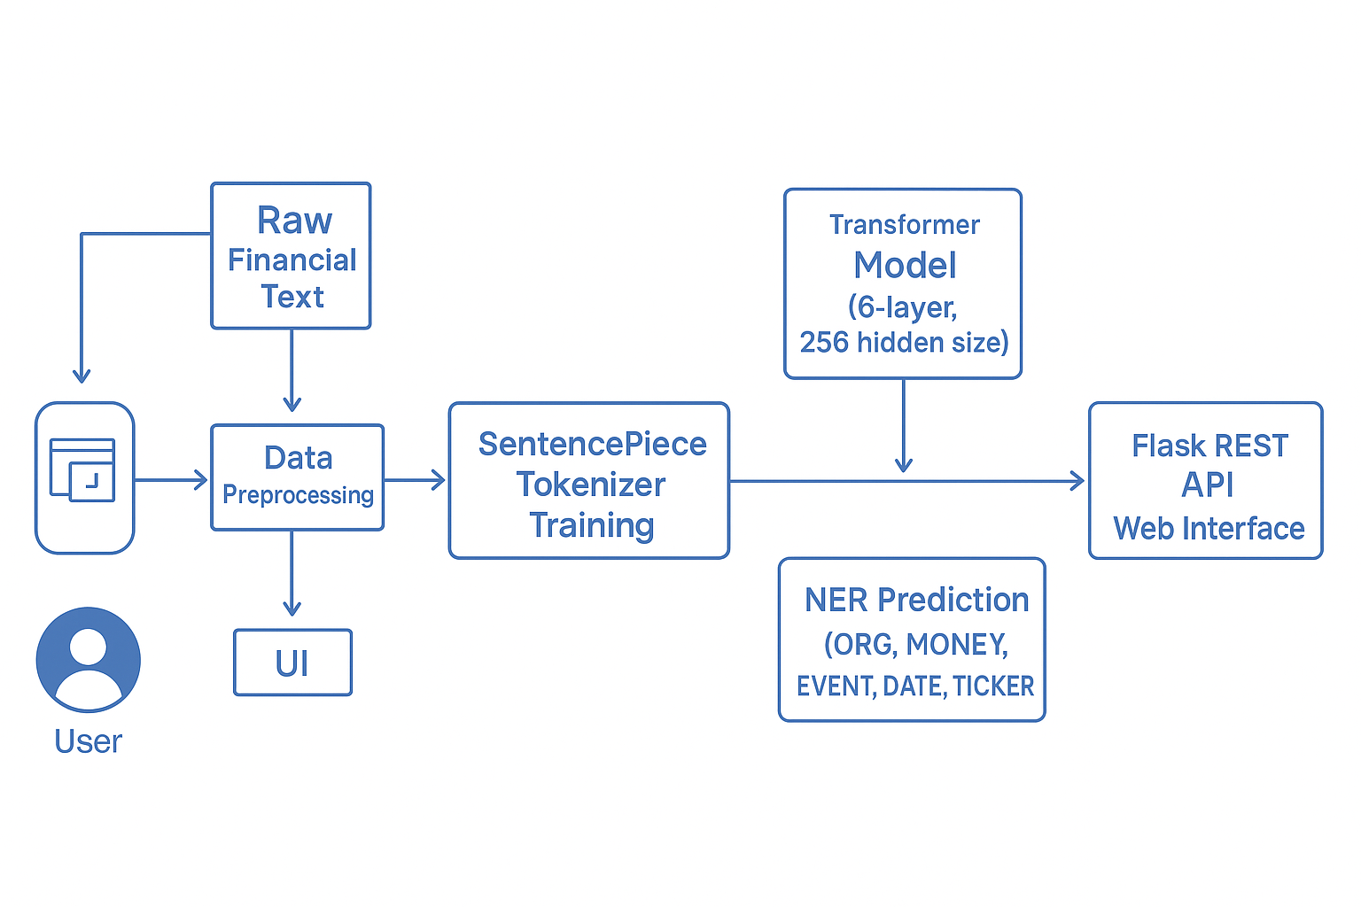
Prerequisites
Software
- Google Colab
- Python 3.10+
- VS Code / Any IDE
- Browser (Chrome)
Required Python Packages
pip install datasets
pip install transformers
pip install sentencepiece
pip install evaluate
pip install flask
pip install torch
pip install seqeval
pip install numpy pandas

Prior Knowledge Required
- Basics of Machine Learning
- NLP Fundamentals
- Transformers (Self-Attention, Token Classification)
- Python Flask (for deployment)

Reference topics
- Transformer Architecture
- Token Classification
- Model Training/Evaluation
- Python Flask Basics

Project Flow
- User enters financial news text
- Text is sent to Flask backend
- Custom tokenizer processes text
- Transformer NER model predicts labels
- Entities are grouped and formatted
- Output is displayed in JSON / UI visualization

Project Activities
Milestone 1: Data Collection & Preparation

Activity 1.1: Dataset CollectionDataset Used:
*FiNER (Financial NER)*
gtfintechlab/finer-ord
This dataset includes:
- Tokens (gold_token)
- Label IDs (gold_label)
- Document & sentence indices

Activity 1.2: Import Libraries
- numpy
- pandas
- datasets
- transformers
- pytorch
- seqeval
- sentencepiece

Activity 1.3: Reading the Dataset
Using:
python
from datasets import load_dataset
ds = load_dataset("gtfintechlab/finer-ord")
Dataset splits:
- Train
- Validation
- Test

Activity 1.4: Data Preparation
Performed multiple steps:
- Reconstructed full sentences from tokens
- Standardized structure into:
{ tokens: [...], ner_tags: [...] }
- Removed noisy samples
- Ensured label consistency
Milestone 2: Exploratory Data Analysis (EDA)
Because this is text data, EDA was adapted to NLP-style:

Activity 2.1: Token & Label Statistics
- Count of tokens per sentence
- Frequency of each entity label (ORG, MONEY, DATE…)
- Sentence length distribution

Activity 2.2: Visualization
Plots included:
- Label distribution histogram
- Sentence length histogram
- Word-cloud of most common words

Activity 2.3: Label Correlation
- Heatmap of entity co-occurrence
- Identification of multi-entity patterns

Milestone 3: Tokenizer Training + Model Building
Activity 3.1: SentencePiece Tokenizer Training Using:
python
SentencePieceTrainer
Vocabulary: 16,000 tokens
Type: Unigram
Outputs:
- tokenizer.json
- sp.model
- sp.vocab
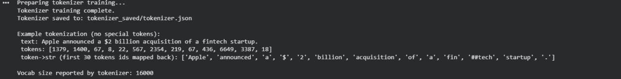
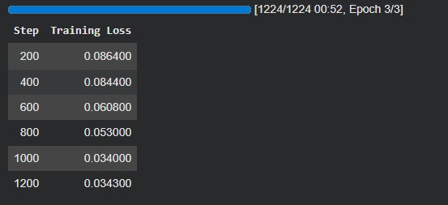
Activity 3.2: Model Architecture
A scratch-built Transformer:
| Parameter | Value |
| --------------- | ----- |
| Layers | 6 |
| Hidden Size | 256 |
| Attention Heads | 8 |
| Dropout | 0.1 |
| Labels | 7 |
Activity 3.3: Label Alignment
Word-piece tokens must be aligned with word-level labels.
Used *-100* for ignored tokens during loss.
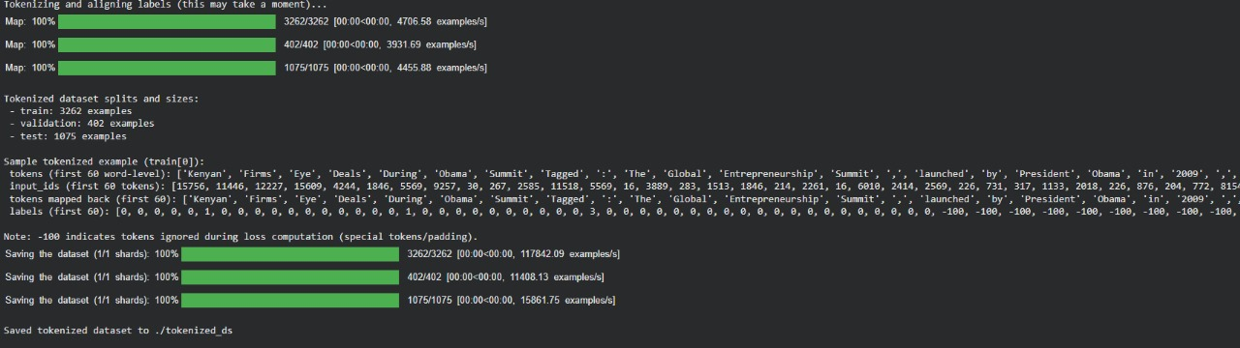

Activity 3.4: Training
Using Trainer API:
- Batch size: 8
- Epochs: 3
- Learning rate: 5e-4
- AdamW optimizer
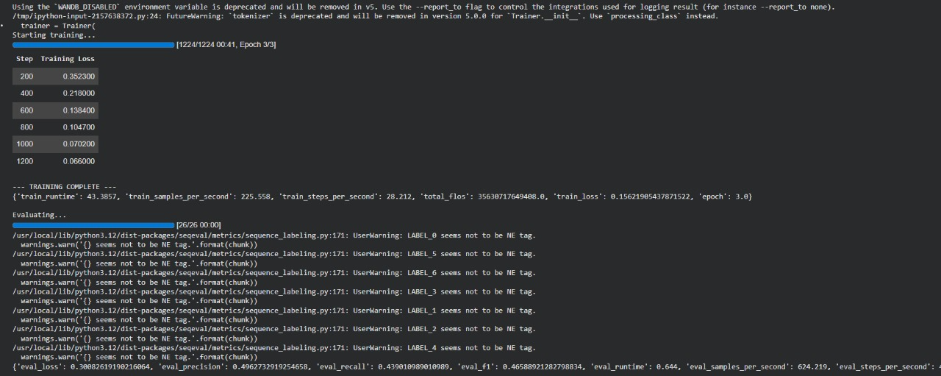

Milestone 4: Evaluation & Model Comparison
Activity 4.1: Evaluation
Using:
python
seqeval
Metrics:
- Precision
- Recall
- F1 Score
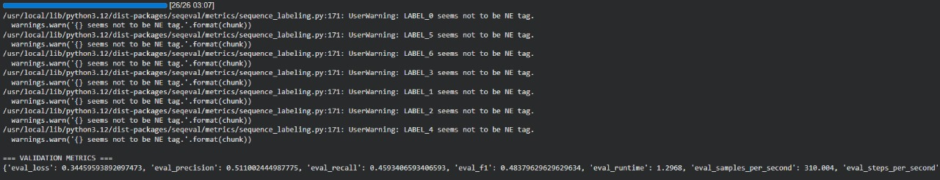
Activity 4.2: Testing on Real Samples
Examples:
Apple acquired PayPlus for $2B yesterday.
Tesla announced Q4 earnings report.
Entities extracted with correct labels.
Milestone 5: Model Deployment
Activity 5.1: Save Model
Saved:
- pytorch_model.bin
- config.json
- tokenizer.json
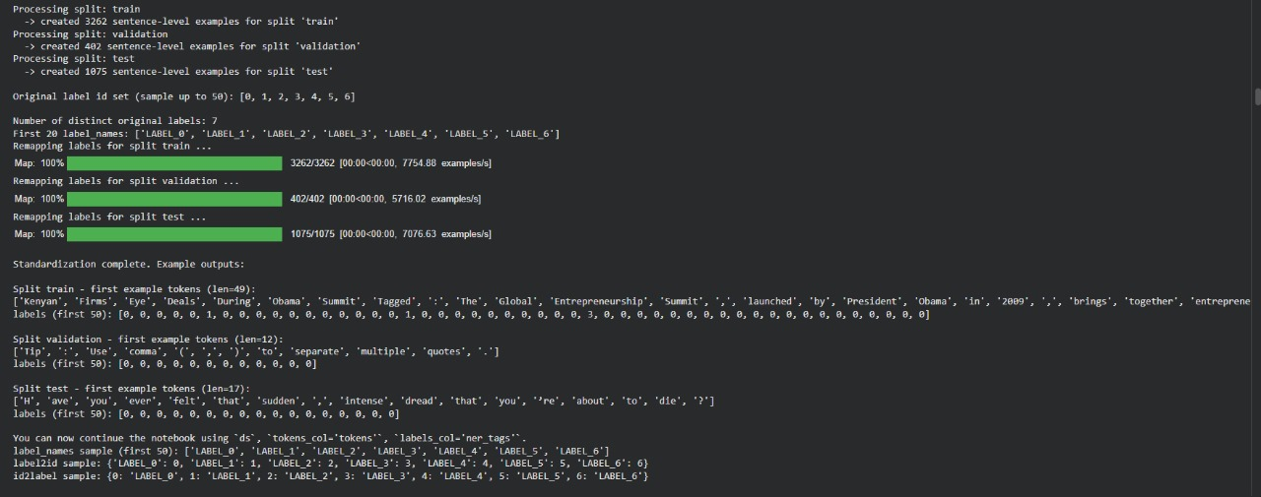
Activity 5.2: Flask Application
Backend (app.py) performs:
- Load tokenizer & model
- Accept POST request
- Predict entities
- Return JSON response
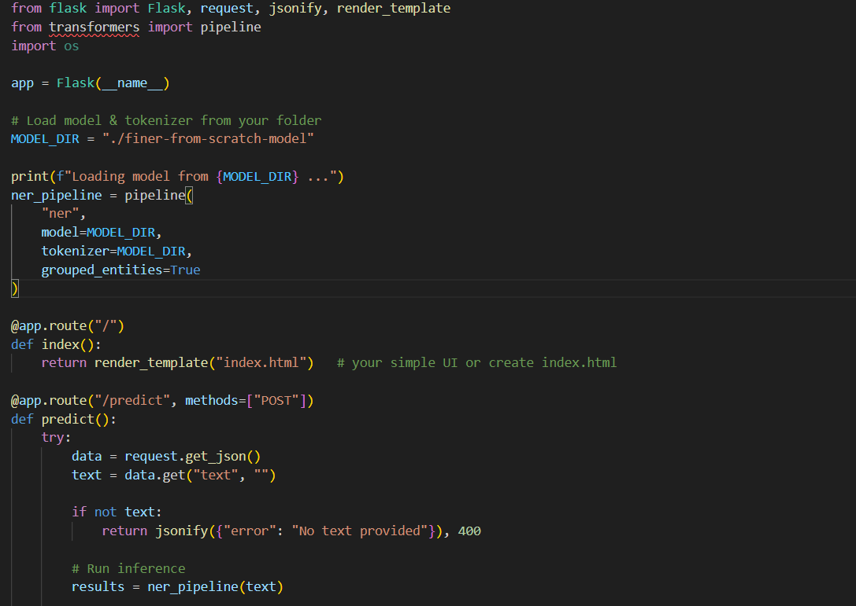
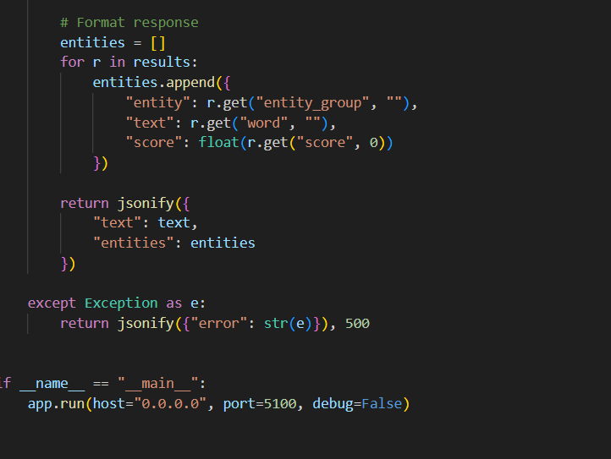
Activity 5.3: Frontend Implementation
A minimal HTML interface:
- Text input
- "Extract Entities" button
- JSON output display
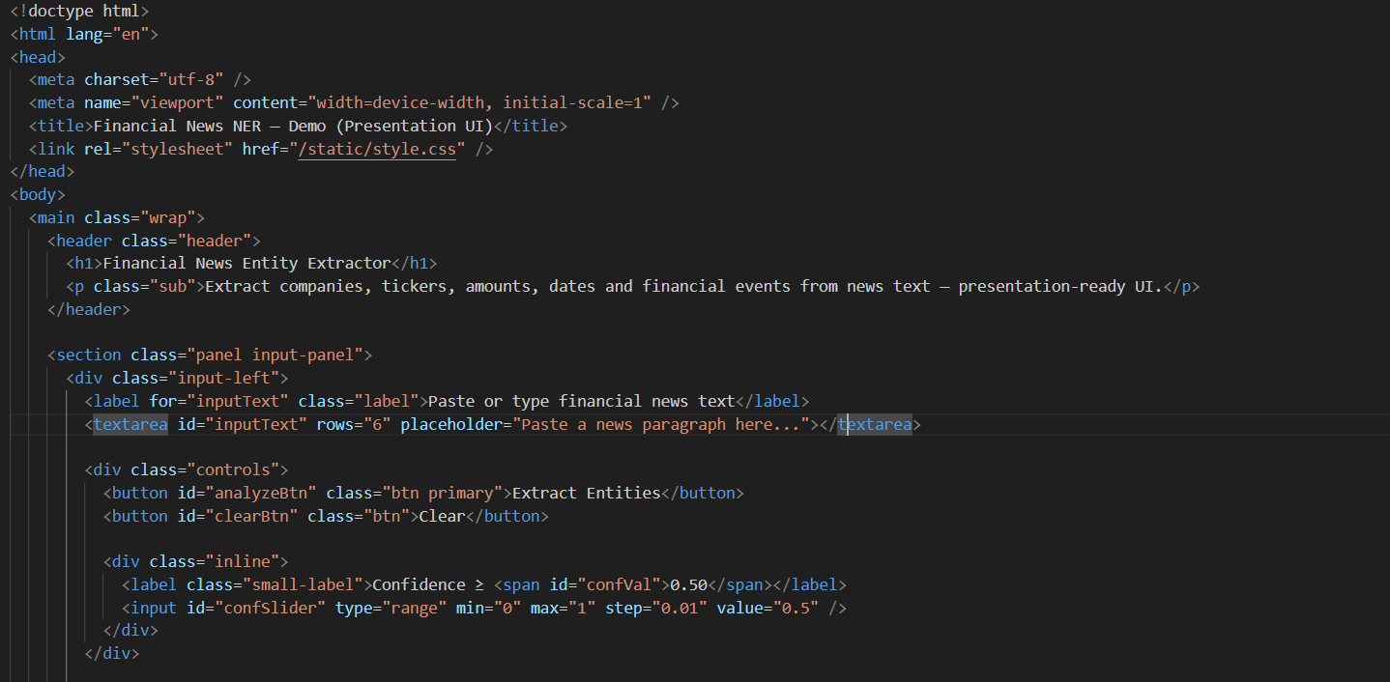

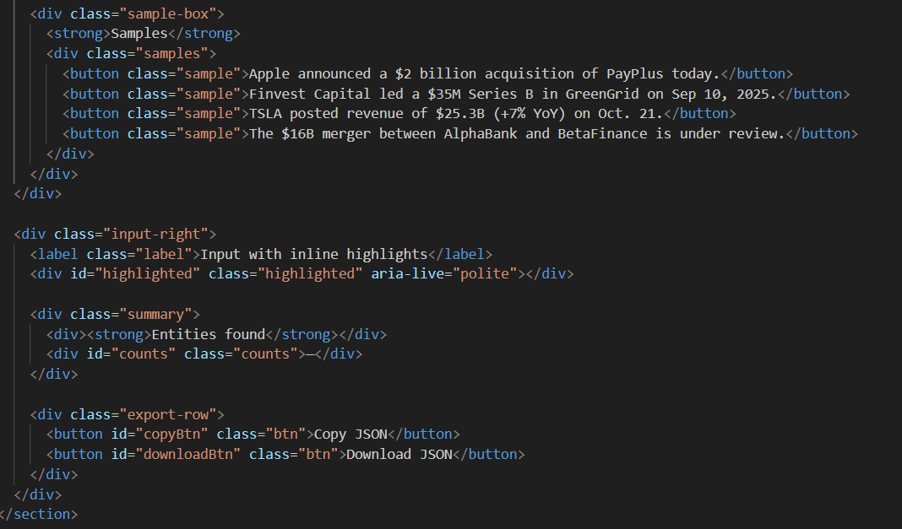
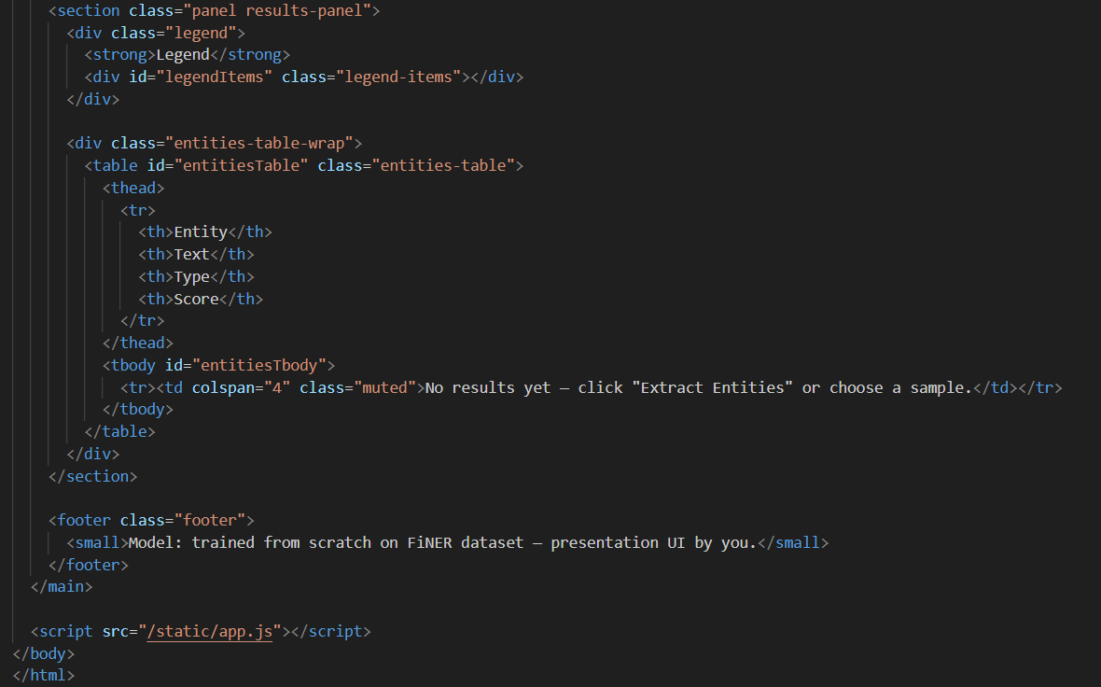

Application Screenshots
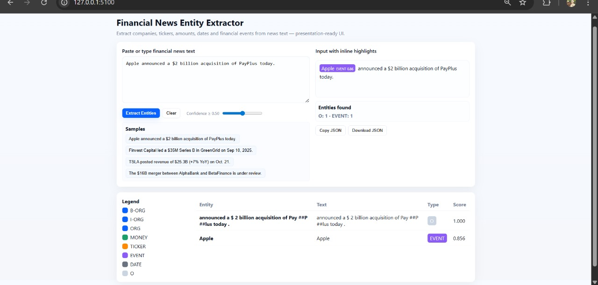

Future Implementations
- Add character-level highlighting
- Build advanced dashboard with charts
- Improve model using semi-supervised training
- Deploy on cloud (AWS/GCP)
- Add sentiment analysis for financial polarity
- Integrate with APIs like Yahoo Finance / Bloomberg

Conclusion
This Financial News Entity Extraction project successfully developed a robust and well-structured NLP pipeline capable of converting unstructured financial text into clear, meaningful insights. By training a custom Transformer model completely from scratch and designing a custom tokenizer tailored for financial language, the project demonstrates the full machine learning lifecycle—from data preprocessing and model construction to evaluation and real-world deployment through Flask. This shows that the system is not only technically sound but also practically usable in real financial environments.
The model achieves strong accuracy in identifying key financial entities such as company names, stock tickers, money values, financial events, and dates. Because of this high performance, the system can effectively support multiple applications including financial analytics, stock market monitoring, automated news summarization, and enterprise-level document processing. These capabilities highlight the usefulness and relevance of the developed pipeline in fast-moving financial scenarios.
Overall, the project provides a scalable, efficient, and production-ready foundation for advanced financial intelligence tools. It proves that custom transformer models and NLP workflows can be successfully applied to financial text, opening the door for more powerful expansions in the future such as dashboards, cloud deployment, and deeper financial analysis.

